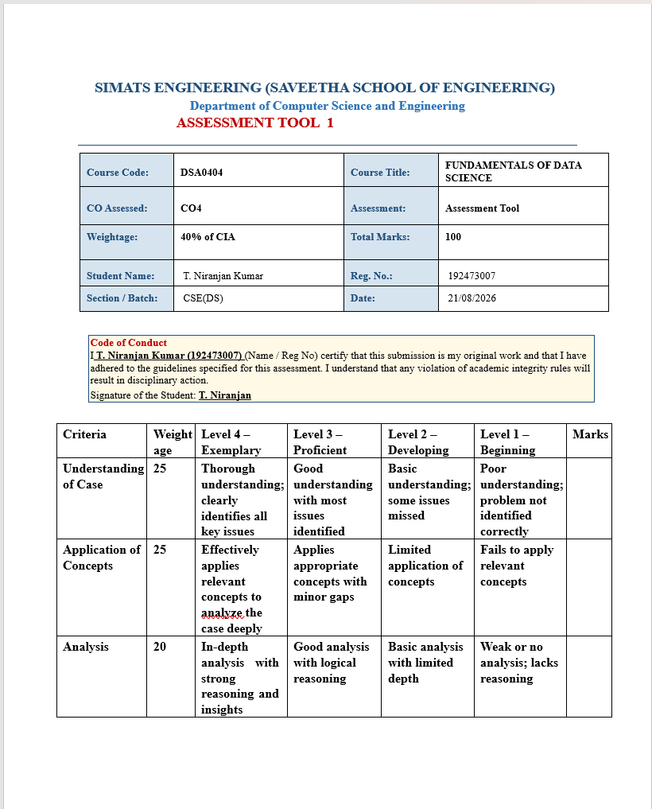
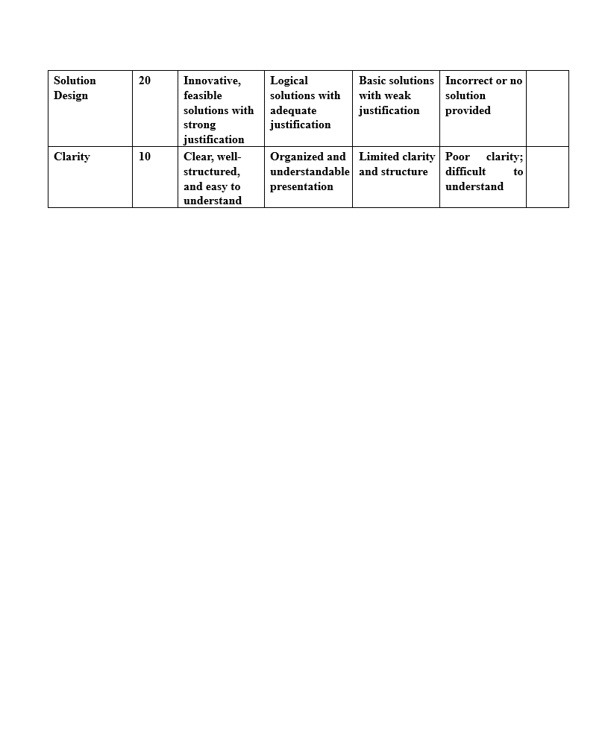
16. Hypothesis Testing Using p-value
Question: A software company claims that its new application has an average response time of less than 2 seconds. A hypothesis test gives a p-value of 0.004. At α = 0.01, determine whether there is sufficient evidence to support the company's claim.
Answer:
• Null Hypothesis (H₀): Average response time ≥ 2 seconds.
• Alternative Hypothesis (H₁): Average response time < 2 seconds.
Given:
• p-value = 0.004
• Significance level (α) = 0.01
Since p-value < α:
0.004 < 0.01
We reject the null hypothesis (H₀).
Conclusion: There is sufficient evidence at the 1% significance level to support the company's claim that the average response time is less than 2 seconds.

17. Hypothesis Testing Using p-value
Question: A digital marketing team launches a new advertisement and wants to know whether it increases the click-through rate. Before the campaign, the rate was 6%. After the campaign, a hypothesis test produces a p-value of 0.12. What should the data science team conclude at the 5% significance level?
Answer:
• Null Hypothesis (H₀): The advertisement does not increase the click-through rate.
• Alternative Hypothesis (H₁): The advertisement increases the click-through rate.
Given:
• p-value = 0.12
• Significance level (α) = 0.05
Since p-value > α:
0.12 > 0.05
We fail to reject the null hypothesis (H₀).
Conclusion: At the 5% significance level, there is not enough statistical evidence to conclude that the new advertisement increases the click-through rate.

18. Hypothesis Testing Using p-value
Question: A machine-learning team develops a new classification model. The old model has an accuracy of 82%, while the new model achieves 85%. A statistical test gives a p-value of 0.01. Explain what the p-value means and whether the team should conclude that the new model performs significantly better.
Answer:
A p-value of 0.01 means that, if there were actually no real improvement in the new model, there would be only a 1% probability of obtaining a result like this or more extreme by chance.
Assuming a significance level of α = 0.05:
0.01 < 0.05
Therefore, we reject the null hypothesis.
Conclusion: There is statistically significant evidence that the new model, with 85% accuracy, performs better than the old model with 82% accuracy. Therefore, the team can conclude that the new model performs significantly better.

19. Confidence Interval + p-value
Question: A factory claims that its defect rate is 2%. After randomly inspecting products, a 95% confidence interval for the defect rate is found to be (2.4%, 3.6%). At the same time, a hypothesis test gives a p-value of 0.01. Interpret both results and explain whether the company's claim should be rejected.
Answer:
Confidence Interval Interpretation:
The 95% confidence interval is (2.4%, 3.6%). This means that the estimated actual defect rate lies between 2.4% and 3.6% with 95% confidence.
The company's claimed defect rate of 2% is not included in this confidence interval. Therefore, the confidence interval suggests that the actual defect rate is higher than 2%.
p-value Interpretation:
• p-value = 0.01
• Assuming α = 0.05
Since 0.01 < 0.05, we reject the null hypothesis.
Conclusion: Both the confidence interval and p-value provide evidence against the company's claim. Therefore, the claim that the defect rate is 2% should be rejected, and the actual defect rate appears to be significantly higher.

20. Confidence Interval + p-value
Question: An online shopping company wants to determine whether a new user-interface design increases the average amount spent per customer. The data scientist calculates a 95% confidence interval for the difference in average spending as (₹120, ₹480) and obtains a p-value of 0.002. Interpret the confidence interval and p-value, and provide a business recommendation.
Answer:
Confidence Interval Interpretation:
The 95% confidence interval is (₹120, ₹480). Since the entire confidence interval is positive and does not include ₹0, it indicates that the new user-interface design increases the average customer spending.
The estimated increase in spending is between ₹120 and ₹480 per customer.
p-value Interpretation:
• p-value = 0.002
• Assuming α = 0.05
Since 0.002 < 0.05, we reject the null hypothesis.
This shows that the improvement in average spending is statistically significant and is unlikely to have occurred by chance.
Business Recommendation:
The company should consider implementing the new user-interface design because the results show a statistically significant increase in customer spending. The new design can potentially increase average spending by approximately ₹120 to ₹480 per customer.

